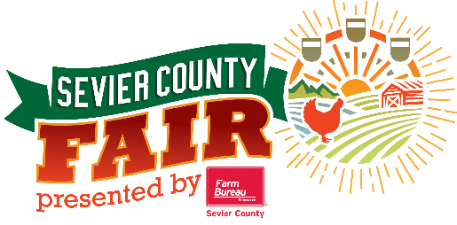
Look-A-Like Lip Sync Competition
Monday, September 5th 7:00pm
Registration Form
Deadline to enter August 16th, 2022 and FREE to enter.

Contestants Name: _________________________________ Age:___ DOB: _____________

Address: _______________________ City: _______________ State: _____ Zip: _________

Phone Number: __________________ Email: ____________________________________

Name of Look-A-Like: _______________________________________________________

Song title you will be lip syncing to: ______________________________________________

You may register online at the website listed below if you prefer. Or you may fill out and
mail to Sevier County Fair, PO Box 6514, Sevierville, TN 37864 or drop off at the
Fair Office at 754 Old Knoxville Hwy, Sevierville, TN 37862.

--------------------------------------------------------------------------------------------------------------------------

Contestant keeps this portion

- Include a picture of your L00k-A-Like for judges to compare you with.
- Your song choice cannot be changed.
- You must provide your music on CD or Pen/Zip Drive only. No phones.
- No age limit and No entry fee!
- Only performers will be allowed on stage during performance.
- Not open to professionals (defined as anyone who makes ½ of their living expenses performing).
- All contestants will use sound system and lighting provided by Sevier County Fair and that will be operated by our technicians only.
- You will be judged on how much you look like the person, your performance, and accuracy on lip syncing to the song.
- This is not a costume contest. Don’t just throw a costume on. You will be judged on how you naturally look like the artist or how much effort you put in to looking like the artist.

Prize Money: 1st Place - $75 2nd Place - $50 3rd Place - $25

Go to www.seviercountyfair.org to register online
or all the fair office at 865-453-0770 for more details.

