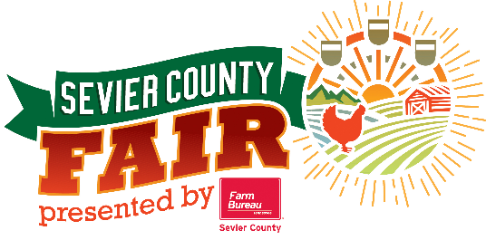
2022 Mullet Contest

If registering online you must do so by August 26th.
You may also register at the Information Booth Daily, no later than 30 prior to contest.

Name: ______________________________________________ Age: _____________

Address: ________________________ City: _____________ State: _____ Zip: _______

Email Address: ________________________________ Phone: ___________________

How long have you been growing your mullet? ____________________________________

Who inspired your mullet? _________________________________________________

Any special care you recommend for a lovely mullet? ________________________________

Who is the biggest fan of your mullet? __________________________________________

2022 Mullet Contest

If registering online you must do so by August 26th.
You may also register at the Information Booth Daily, no later than 30 prior to contest.

Name: ______________________________________________ Age: _____________

Address: ________________________ City: _____________ State: _____ Zip: _______

Email Address: ________________________________ Phone: ___________________

How long have you been growing your mullet? ____________________________________

Who inspired your mullet? _________________________________________________

Any special care you recommend for a lovely mullet? ________________________________

Who is the biggest fan of your mullet? __________________________________________

